**CONTACT DETAILS & DONATIONS**

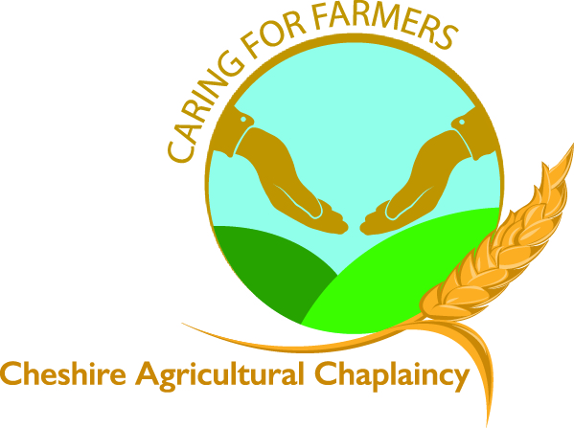

Please complete and email to sponsors@agchap.com

**DONATION & GIFT AID DECLARATION**

**Churches Together In Cheshire – Registered Charity No 1115015**

**Registered address – Methodist District Office, Bishops Wood, NANTWICH CW5 7QD**

**Details of Donor** *(Note: Gift Aid only applies to donations made by individuals i.e. not by companies)*

Title ………………… Forename ………………………………………….

Surname…………………………………………………………………………………….

Address ……………………………………………………………………………………………………………………………………………………………………………..

…………………………………………………………………………………………………………………………….. Postcode …………………………….

Email ……………………………………………………………………………………………………………………………….

Tel: …………………………………………………………………………………………………………………………………..

I wish to donate: -

A one-off donation of £…………………………………………………………………………………

A regular donation of £ ………………………………………………………………………………… a month by standing order

I want the Charity to treat all donations I have made for the four years prior to this year (2024) and all donations I make from the date of this declaration until I notify you otherwise, as Gift Aid donations.

I will make donations by:- *(Please tick box as required)*

Bank Transfer/**Standing Order**  Cheque 

Bank Details: CAF Bank Ltd. Sort Code: 40-52-40 Made Payable to “Agricultural Chaplaincy”

Account Number: 00015858 Cheshire” post to Helen Rutter, Mount Pleasant Farm, Ridley, Tarporley, Cheshire CW3 9RY

You must pay the amount of income tax and/or capital gains tax at least equal to the tax that the charity reclaims on your behalf (Currently 25p for each £1 you give)

Signed ……………………………………………………………………………………………………. Date ……………………………………………………….

**The Cheshire Agricultural Team, thank you for your very kind donation.**

